**MouseChat User Guide**

**MouseChat Homepage**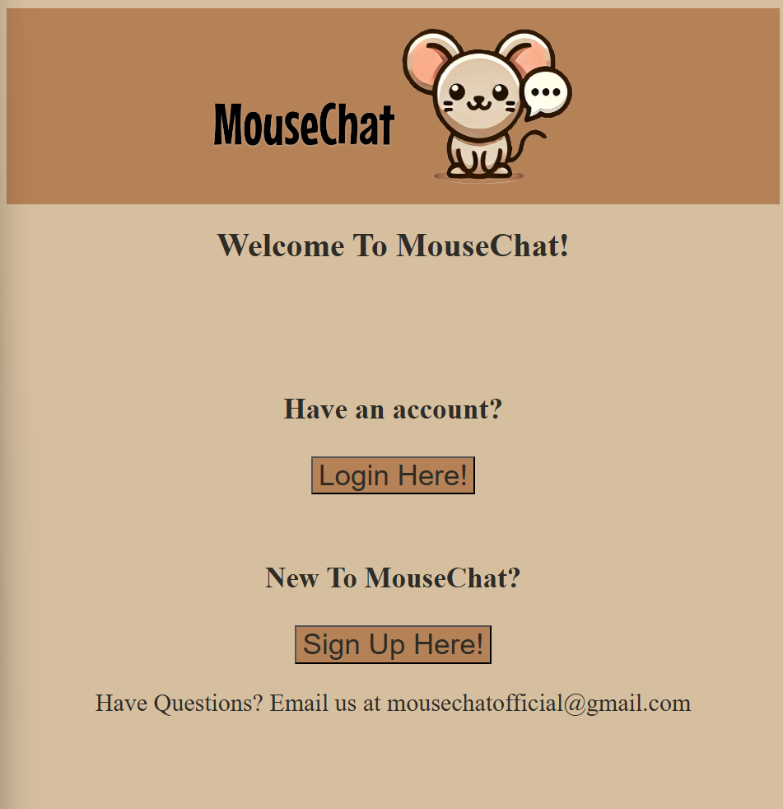

On the MouseChat homepage, (/)the user is presented with a header with our logo, a welcome message, a login button, a signup button, and a footer. The Header acts as a way to return to the homepage by clicking on it. The “Login Here!” button redirects the user to the login page. The “Sign Up Here!” button redirects the user to the signup page. The footer includes our official company email address in case the user has questions about our site.

**MouseChat SignUp**

On the MouseChat sign up page, (/signup) the user is presented with the standard MouseChat header logo and the footer. The User sees a message prompting the user to sign up and four separate input fields in a column down the page ending in a button that prompts the user to sign up. The first field prompts for a username, the second prompts for a password, the third prompts for the all important favorite cheese, and the final prompt is for an image upload that will be used as the User’s profile picture. The profile picture selection allows you to upload a jpg/jpeg only as your user profile picture. If all fields are filled in correctly, and the signup button is clicked, then a new user is created and redirected to the login page. If the username is already taken, an error occurs, the sign up page is reloaded and the user is prompted to input a different username. Upon a successful signup, the password is hashed using a hash function from the bcrypt module, and stored in the database with other user information. 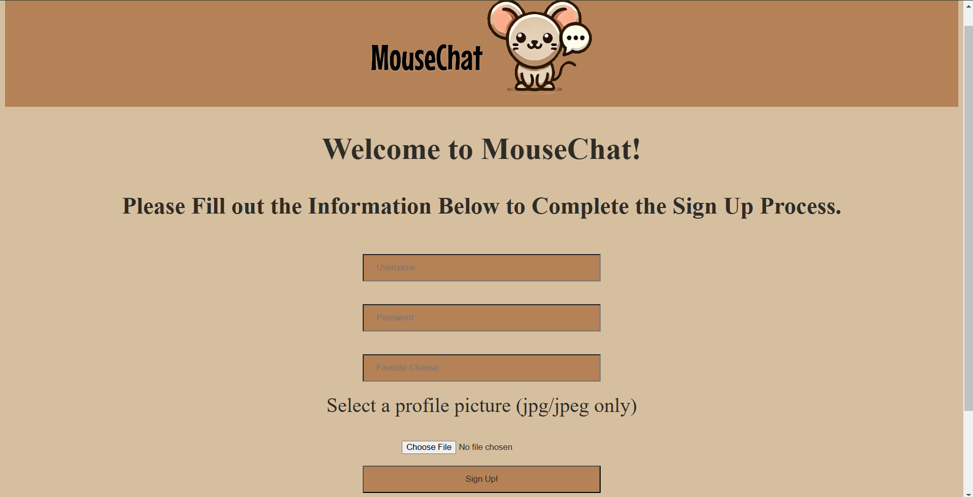

**MouseChat Login**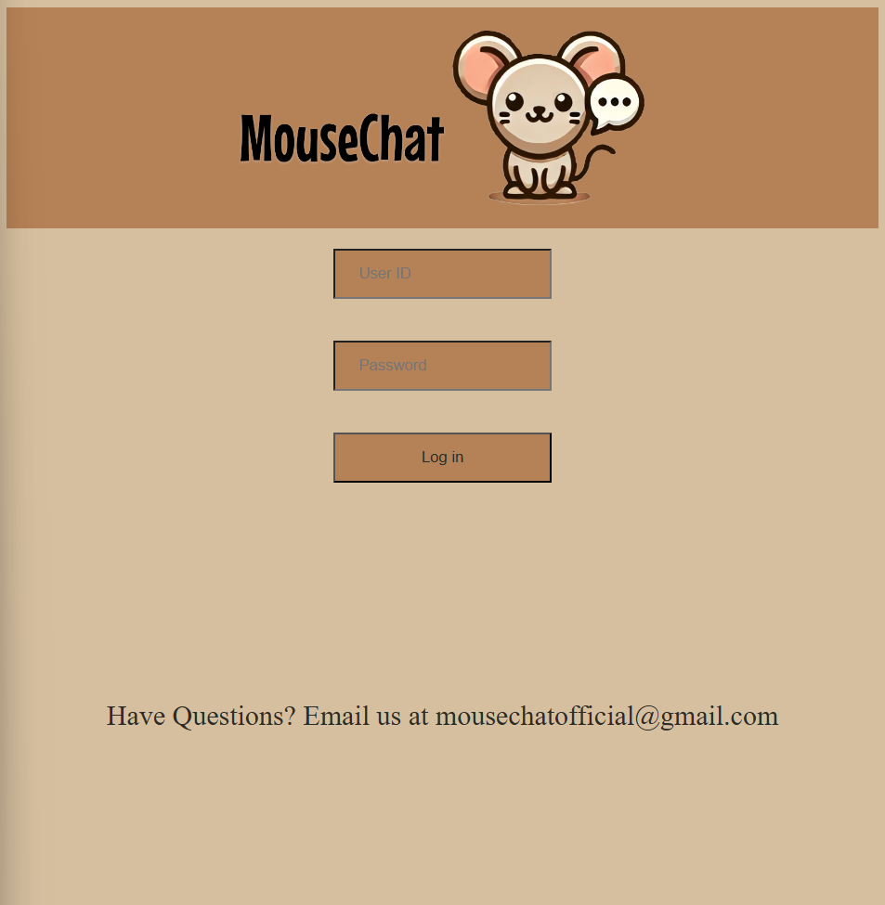

On the MouseChat login page, (/login) the user is presented with the standard MouseChat header logo and the footer. They also see two text boxes and a button. The first text box is the User ID box. This text box is where the user would type in their existing username/User ID. The second text box is the Password box. This box is where the user would type in their existing password. To login, the user would enter their existing and corresponding login information and click the “Log in” button.

**MouseChat Protected Page**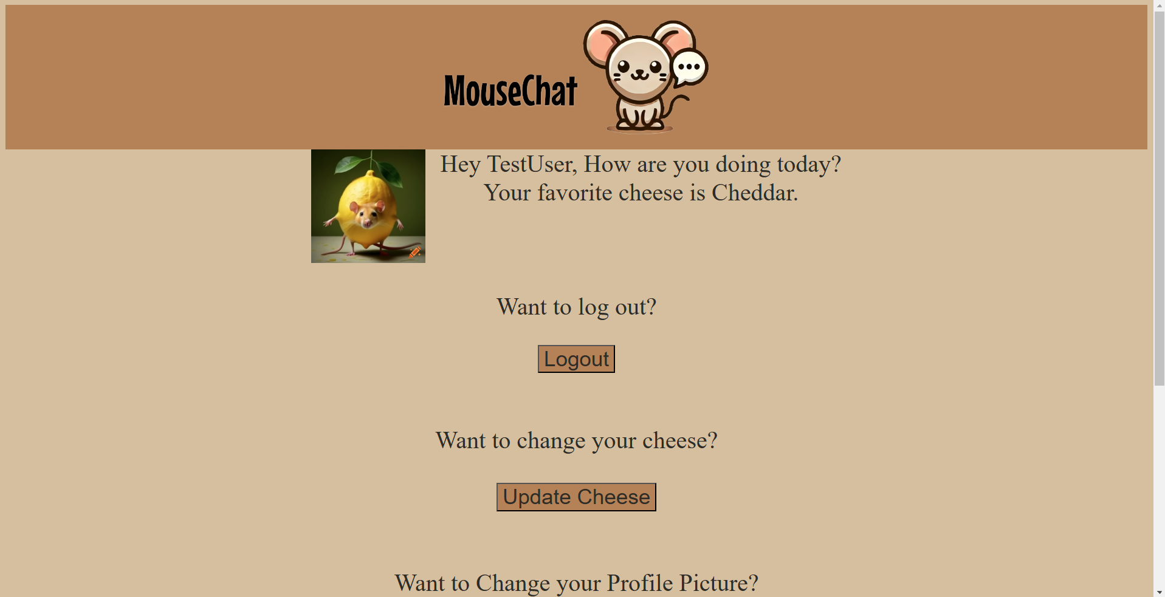

The user’s protected page (/protected) is accessed if and only if they have logged in. There are many parts to this page. There is the Header and footer that has been consistent throughout the site. There is a message that says “Hey, (Your User Name). How are you doing today? Your favorite cheese is (Cheese you selected when creating your account)”. Next to the message is the profile picture you selected. There are many buttons to navigate the site and account-specific areas. If the user wants to logout of their account, they can press the “Logout” button. If the user wants to change what their favorite cheese is, they can press the “Update Cheese” button. If the user wants to change their profile picture, they can press the “Update PFP” button. IF the user wants to delete their account, they can press the “Delete User” button.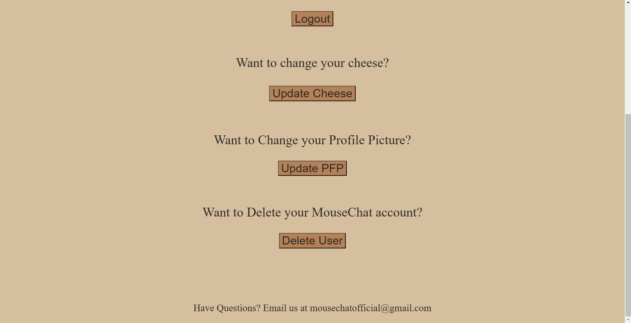

**MouseChat Logout**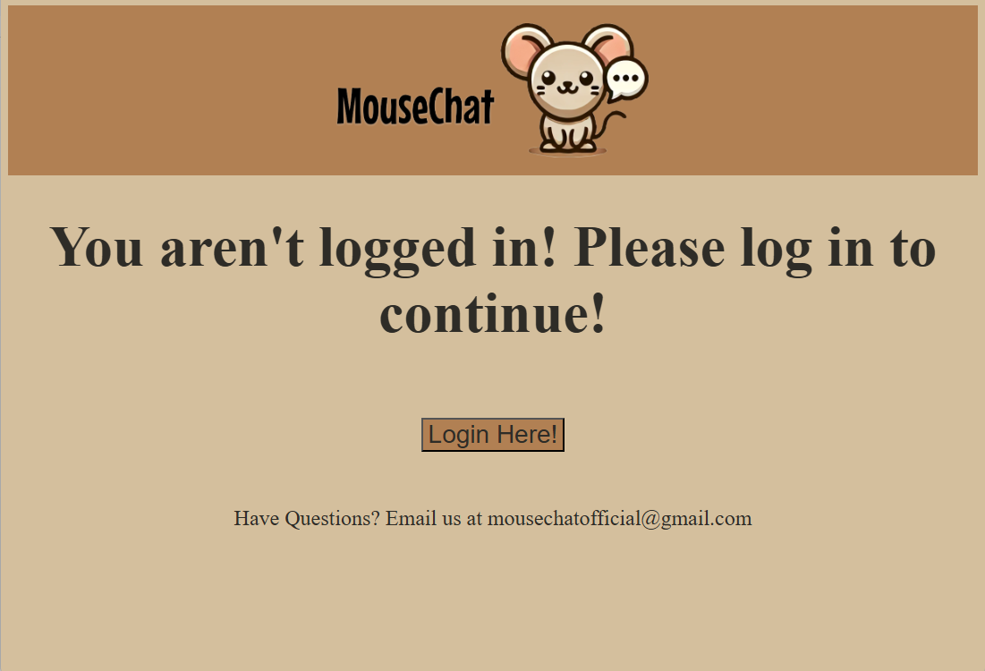

Upon clicking the logout button on the protected page, the user is logged out and redirected back to the login page. After logging out, the user will not be able to access the protected page or any of the pages linked to from the protected page without logging in again. If a URL is entered that would redirect to one of those pages, a not logged in page will render instead telling the user to login to access this page. The page has a “Login Here!” Button that redirects users to the login page along with the standard header and footer.

**MouseChat Update User Cheese**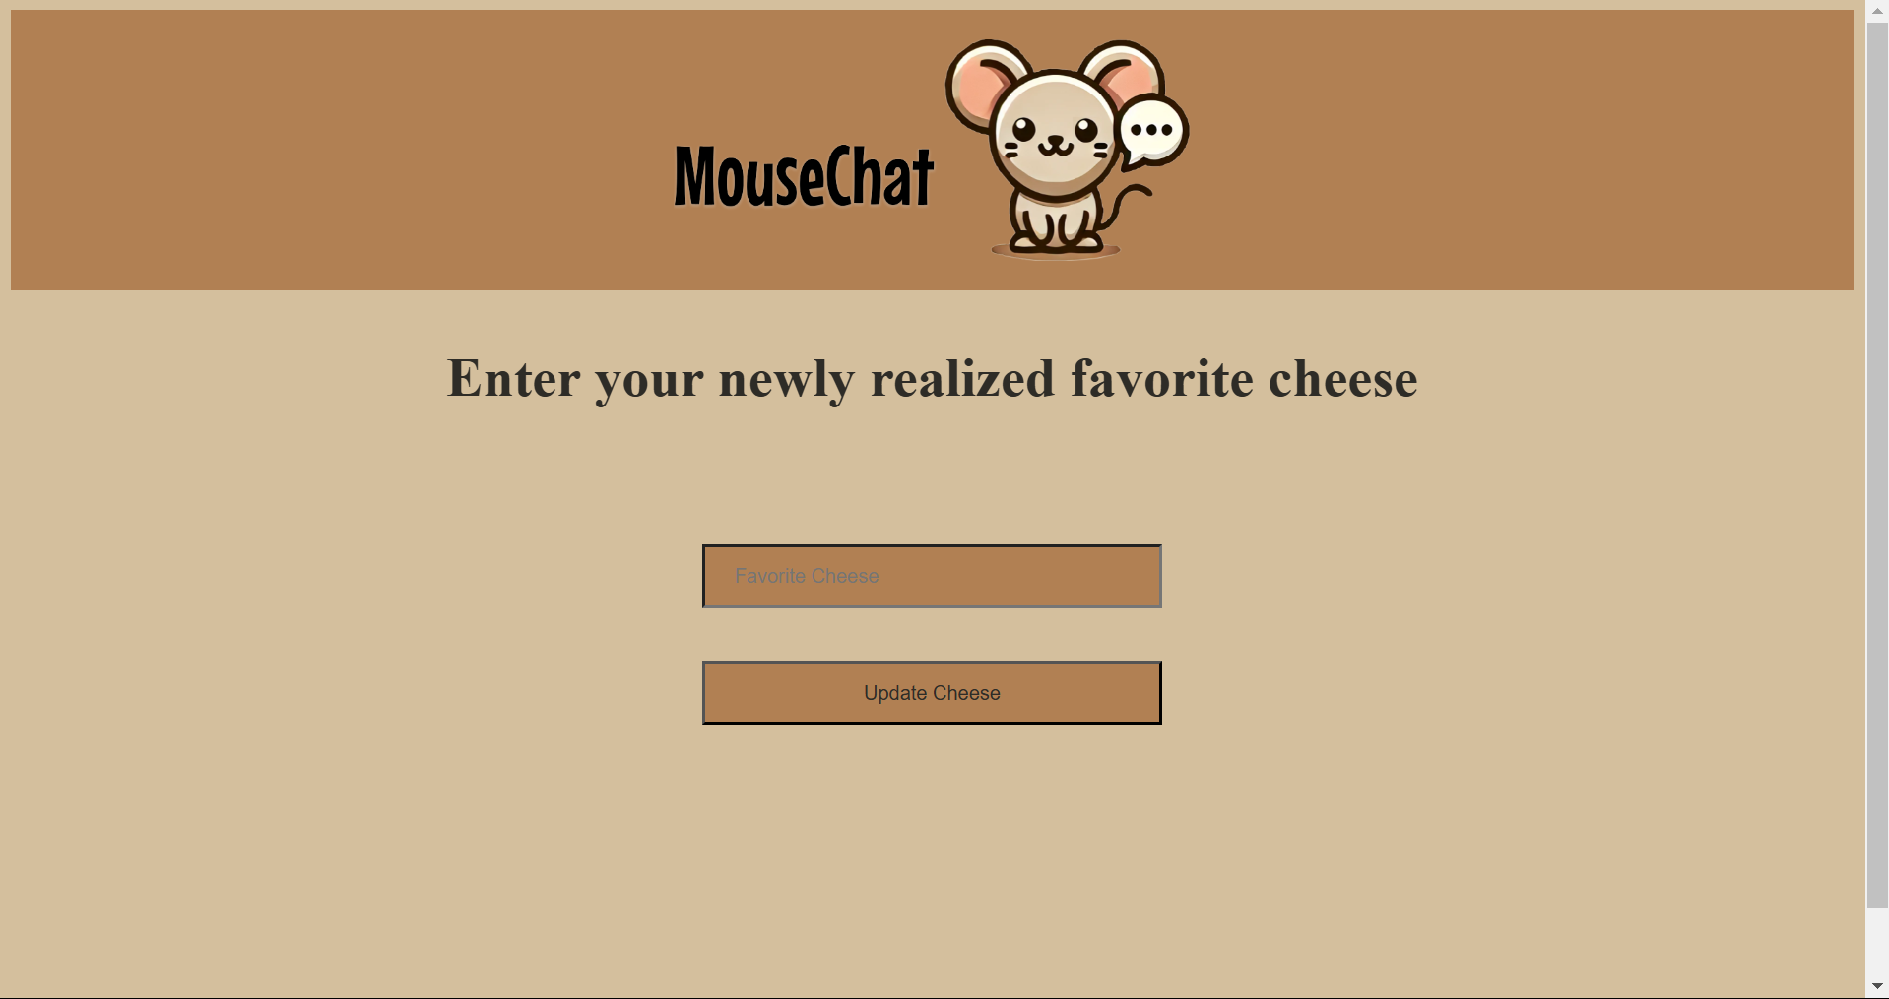

On the MouseChat update cheese page, (/updateUserCheese) the user is presented with the standard MouseChat header logo and the footer. This page is protected, and a user must be logged in to be able to access it. The user is presented with the prompt to “Enter your newly realized favorite cheese” and is presented with an input text box for their favorite cheese and a button that reads “Update Cheese”. Upon entering their newly favorite cheese and pressing the button, the database entry matches the user credentials of the currently logged in user’s session, and updates that entry’s favorite cheese. The user session is then set again to now include their updated cheese preference, then redirects to the protected page, displaying the most up to date cheese information.

**MouseChat Update User Profile Picture**

On the MouseChat update user profile picture page, (/updateUserPFP) the user is presented with the standard MouseChat header logo and the footer. This page is protected, and a user must be logged in to be able to access it. On this page the User is prompted to select a new profile picture, and the User will see a file selector and a button that says “Update”. When a JPEG/jPG file is selected and the update button is clicked, the profile picture will be updated in the database entry matching the credentials of the current logged in User session credentials. The user session is then reset with this new profile picture before redirecting back to the protected page. This allows the protected page to load the new pfp, as it loads information based off of the user session info.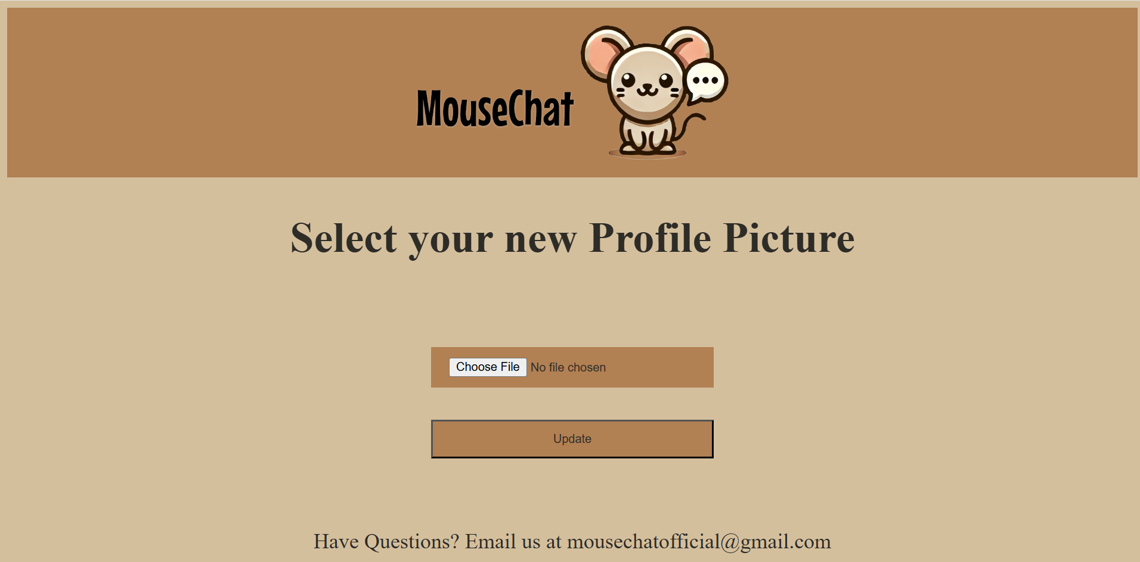

**MouseChat Delete User**

On the MouseChat delete user page, (/deleteUser) the user is presented with the standard MouseChat header logo and the footer. This page is protected, and a user must be logged in to be able to access it. The user is presented with two input boxes and a button, as well as text prompting the user to input their user information to confirm deletion. The first text box asks for username, and the second asks for password, the button reads “Delete”. Upon entering information for both fields and pressing the delete account button, if the information matches a user in the database and matches the user’s session credentials then the account is deleted and the user is redirected to the homepage. If the information entered does not match a user in the database, and/or does not match the session credentials, an error will be displayed and the page re-rendered. However this will only happen after the user session is explicitly remade and set, to ensure that the user session credentials remain the same between attempts. 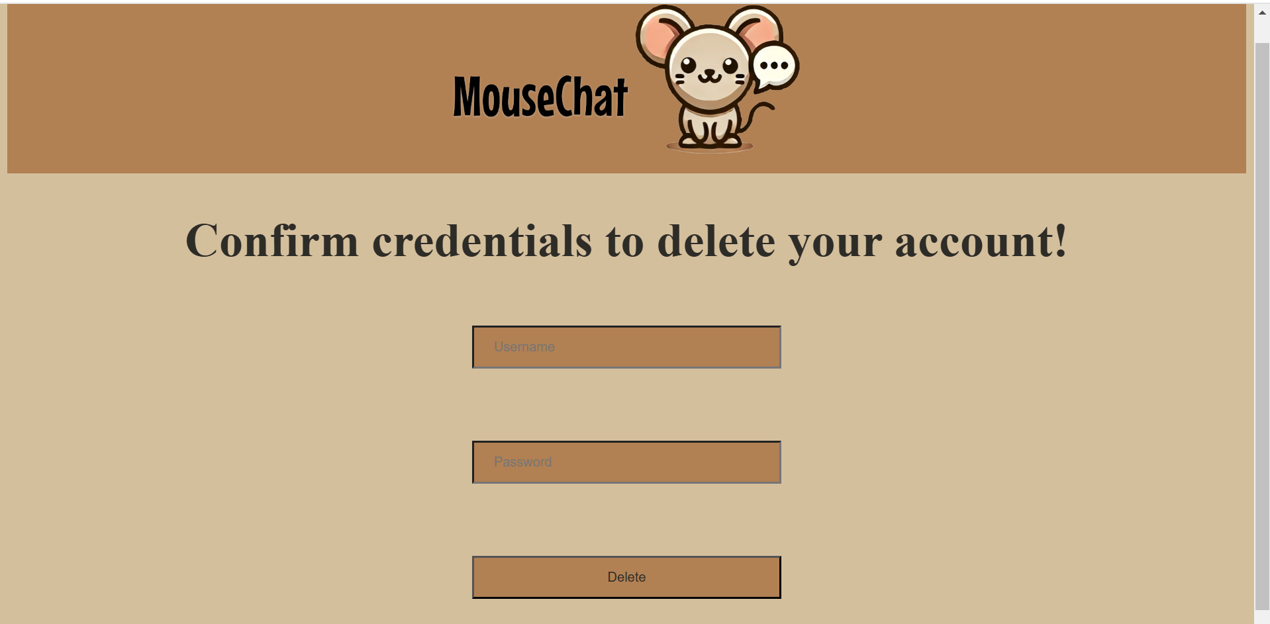

Trello Link: [https://trello.com/invite/b/66d871423be88469a3de8f77/ATTI1efbdd3191c1f4e916a7badd](https://trello.com/invite/b/66d871423be88469a3de8f77/ATTI1efbdd3191c1f4e916a7baddc86d2cbd7E88FF76/mousechat)

[c86d2cbd7E88FF76/mousechat](https://trello.com/invite/b/66d871423be88469a3de8f77/ATTI1efbdd3191c1f4e916a7baddc86d2cbd7E88FF76/mousechat)